# RESULTS

This section presents the outcomes of the simulation and numerical experiments conducted with the proposed model. The results are depicted graphically to enhance clarity and aid visualization.

For our initial result, we conducted a test to examine whether the two colonies exhibit identical intra-colony dynamics as described in our reference paper [9]. **Figure 1** illustrated the dynamics of these two distinct colonies under conditions where there is no drift, and both colonies remain healthy.

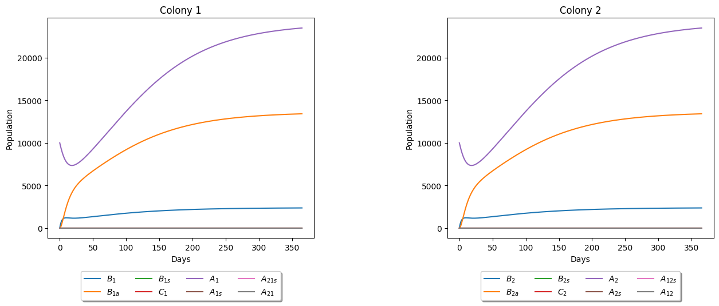

Figure 1. Intra-colony dynamics of the two healthy colonies in the absence of drifting. The parameter values used are in Table 3 except that . The initial conditions also of the state variables are .

To further assess the impact of additional parameters on intra-colony dynamics, we ran a test involving infection without drifting in both colonies, comparing the outcomes to those outlined in the reference paper [9]. The results are depicted in the following figure.

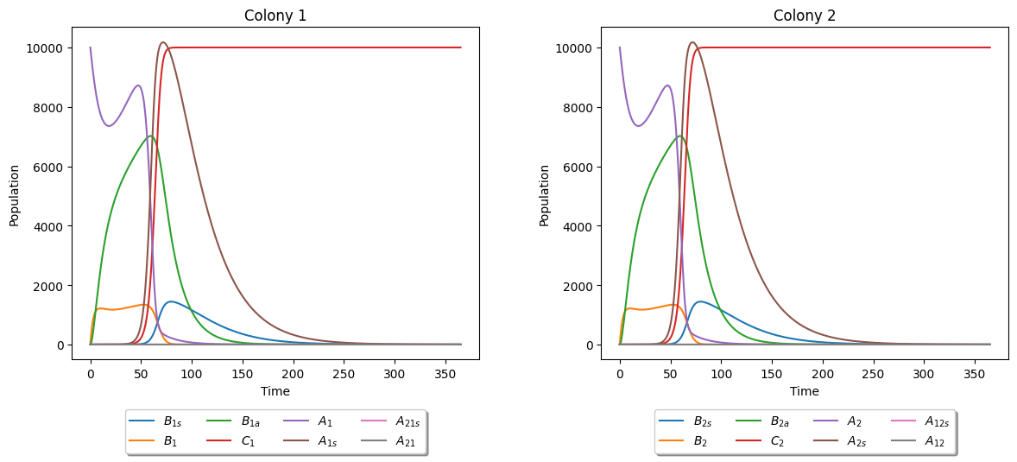

Figure 2. Intra-colony dynamics of the two infected colonies without drifting. The initial condition here are , which means that there is an infected adult in both colonies.

Both **Figure 1** and **Figure 2** demonstrated that the inclusion of additional parameters for inter-colony behavior does not alter the intra-colony dynamics of the original model. This outcome signified a favorable result, allowing us to proceed to the simulations of inter-colony dynamics.

For the first result of inter-colony dynamics, we incorporated the drifting behaviour of honeybees into the model of the two healthy colonies. The parameters, , and for all is incorporated and the results are shown in the figure below.

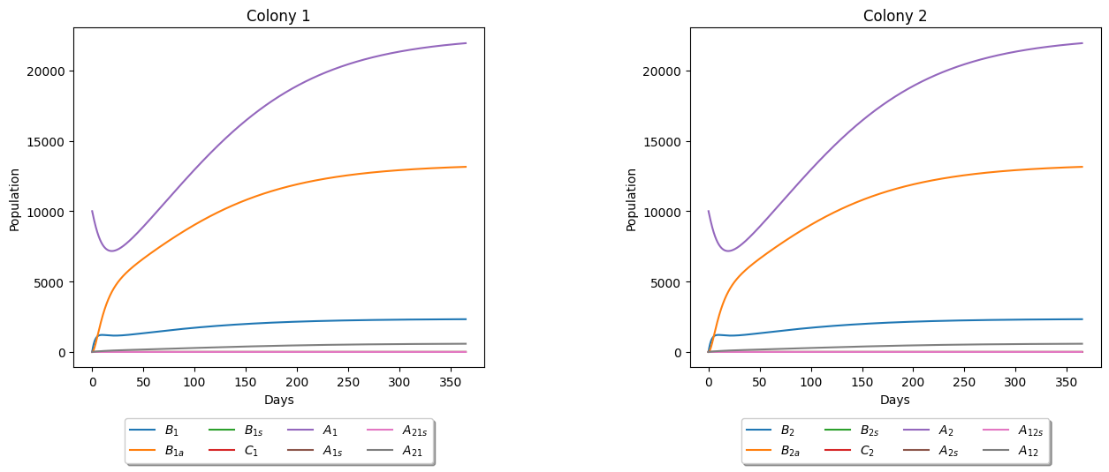

Figure 3. Dynamics of Two Healthy Colonies with Drifting Behavior. The parameters used are in Table 3 except that for all . The initial conditions are also indicating that both are healthy.

The graph illustrated that when drifting occurs, the behavior of the colonies remains largely similar to when there is no drifting, albeit with the addition of foreign bees to the colony dynamics. Notably, there is only a marginal difference in the population of the original bees within the colony, but this is accompanied by the addition of the population of foreign bees. Based on the findings from **Figure 3**, we can also determine the percentage of honeybees that have drifted from the other colony, as further illustrated in **Figure 4**.

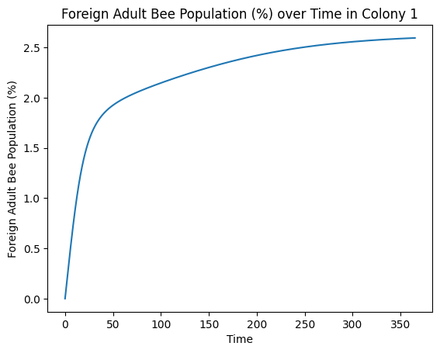

Figure 4. Percentage of drifted honeybees over time. This example from Colony 1 demonstrates behavior similar to that of Colony 2, as evidenced by the results in Figure 3. Therefore, we presented the results for Colony 1, recognizing their equivalence to those of Colony 2.

To further analyze the impact of drifting on the colony, we varied the drifting rate by adjusting the parameter as detailed in **Table 3**. Specifically, we conducted 10 batch runs with drifting rates ranging from to for a healthy Colony 1. The resulting effects are depicted in **Figure 5**.

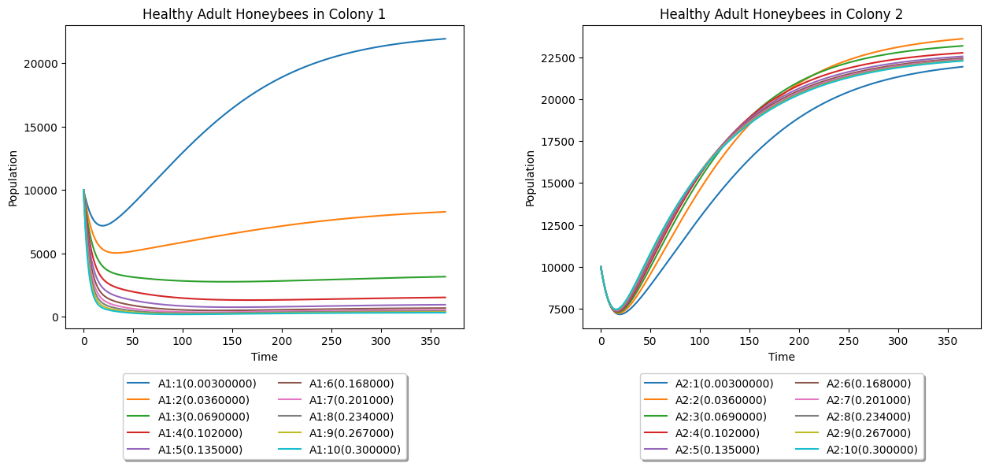

Figure 5. Effects of different values of drift rate to the healthy Colony 1.

From the graph above, we observed that as the drifting rate increases for a healthy Colony 1, it may result in a weakened colony, potentially leading to collapse, particularly at higher drift rates.

Now, we delved deeper into studying the parameters influencing the dynamics of a healthy colony in drifting. In the following heatmap, we varied both the drifting rates, and , of the two colonies.

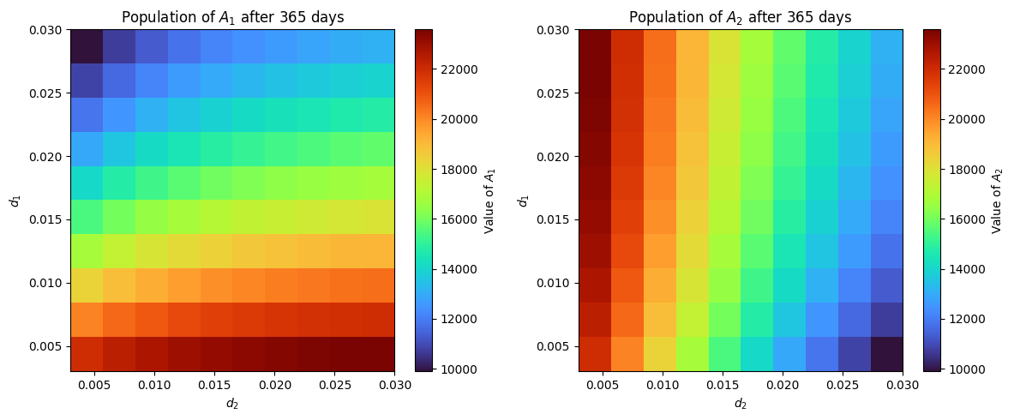

Figure 6. Dynamics of adult honeybees in two healthy colonies with varied drifting rates

The heatmap above illustrated the outcomes for the adult honey bee populations of Colony 1 and Colony 2, indicating whether they will survive or collapse as both their drifting rates are varied. From this analysis, we can conclude that both colonies will survive regardless of whether drifting is at 0% or 100%, as long as the percentage of forager bees (honeybees of an appropriate age capable of leaving the colony) in both colonies remains at 30%. If we include varying the percentage of forager bees and expand the range of from 0% to 100%, the resulting heatmap is displayed below.

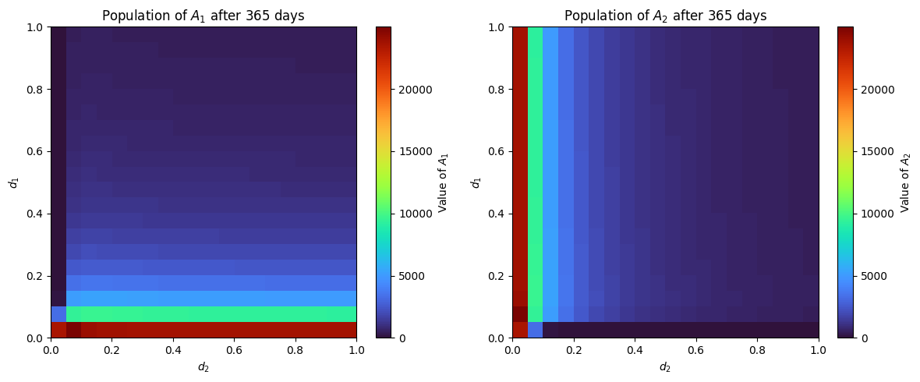

Figure 7. Dynamics of two colonies with varied drifting rates including the percentage of forager honeybees.

From the heatmap, we can identify points where colony collapse occurs. While there isn't a specific percentage of the total population that guarantees collapse, as colony losses are less frequently associated with collapse [6], we can set collapse as occurring when the percentage of the current population to the original initial population is less than 1% (1000). In the heatmap, areas with a deeper blue color indicate collapse.

Additionally, we analyzed the combined effects of drift rate ​and return rate ​ on Colony 2 to determine whether it will survive or collapse under varied parameters. By varying and and plotting this in a heatmap, it can visualize how these two parameters interact and influence each other within the context of honeybee behavior and colony dynamics. Their potential implications are:

* High , Low : This scenario suggests high levels of drift, where bees frequently leave their original colony but successfully integrate into new colonies. This could be due to weak guarding behavior in the receiving colony or aggression from resident bees, leading to the drifting bees either dying or becoming lost outside the two-colony system.
* Low , High : Here, while bees may initially show less inclination to drift, those that do are unsuccessful at integrating into other colonies. This may imply a less hospitable environment outside or strong guarding behavior by the receiving colony.
* High , High : This combination could indicate a dynamic in which bees frequently drift but struggle to integrate into new colonies, possibly suggesting an unhealthy colony or an inhospitable network of colonies.
* Low , Low : This scenario may suggest a stable colony environment with minimal drifting and few bees returning to their original colony, indicative of a well-connected network of colonies.

In the following figure, we analyzed the effect of varying both the drift rate and return rate in Colony 2.

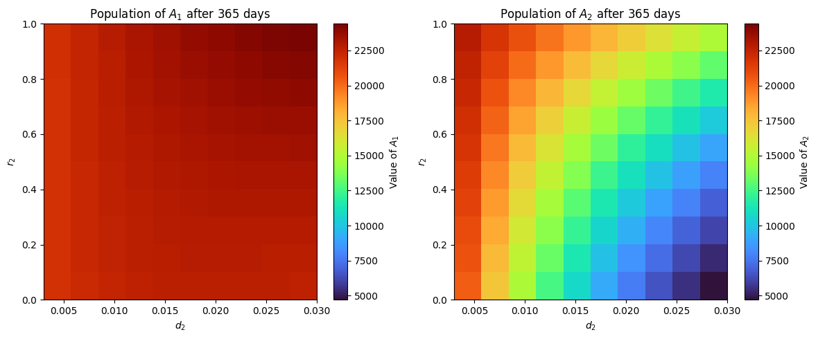

Figure 8. Effect of varying drift rate and return rate to the survival of the adult honeybees.

From the heatmap shown in **Figure 8**, we can see that adult honeybees in Colony 2 still survived, however it became weak, even when there is no return rate and has high drift rate in Colony 2. The colony survival under these parameter values is further illustrated in the figure below.

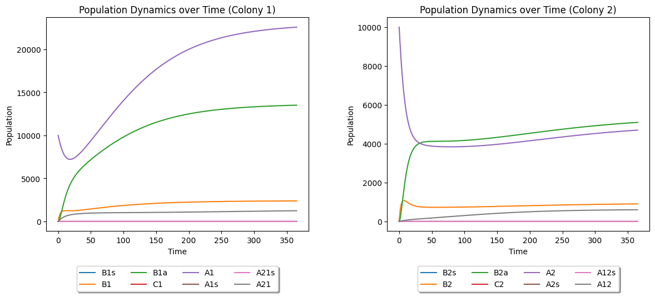

Figure 9. Inter-colony dynamics of the two healthy colony when and on Colony 2.

Finally, in this scenario, if we also vary the percentage of foragers and expand the range of from 0% to 100%, the survival of Colony 2 is depicted in the figure below.

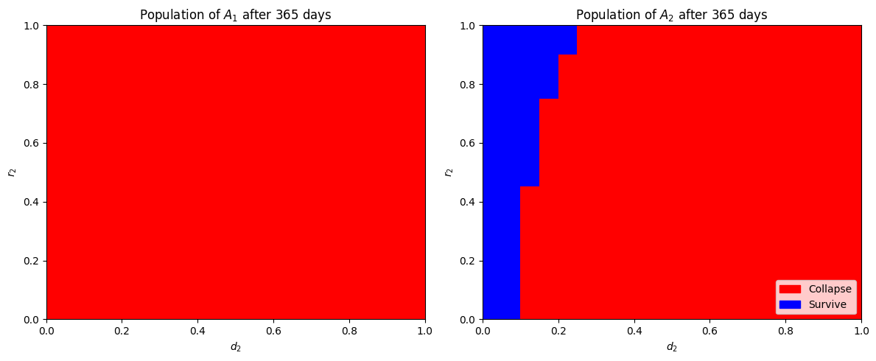

Figure 10. Colony 2 survival heatmap.

We can further explore various combinations of parameters to examine the survival or collapse of a healthy colony. However, we will now shift our focus to the primary objective of this study, which involves integrating AFB infection into the inter-colony dynamics. For the first simulation involving the AFB infection, we started by adding an infected adult to Colony 2. The results are shown in **Figure 11**.

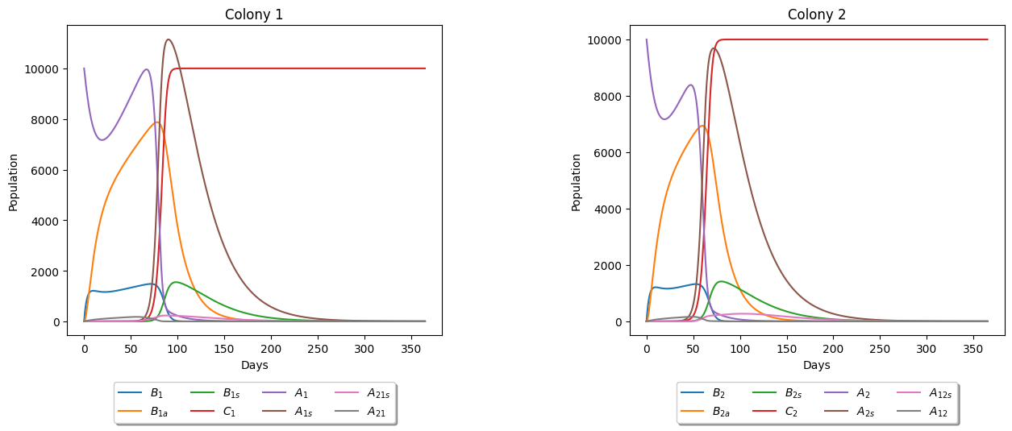

Figure 11. Dynamics of the two colonies with drifting infected adult honeybee from Colony 2. The parameters used here is also in Table 3. The initial conditions are , indicating the presence of an infected adult in Colony 2.

From the graphs above, it is evident that both colonies experience mortality between 250 to 300 days after the infection begins in Colony 2. Interestingly, despite the infection originating in Colony 2, the number of infected adult honeybees in Colony 1 peaks higher than that of Colony 2 over time, potentially increasing the risk of spreading the infection to other colonies when a portion of infected bees in Colony 1 drift to neighboring colonies beyond the two-colony system in the model. This result aligns with findings from Betti et al.'s paper [3], where the second colony in their study peaks slightly higher than the source colony. However, the peak we observed is more pronounced. Lastly, our results from Berkeley Madonna suggested that drifting may actually help decrease the spread of infection in both colonies when one infection originates in the source colony. This finding is by some means consistent with the results reported by Betti et al. [3]. The results we got from Berkeley Madonna are summarized in the tables below.

Table 1. Days of Last Adult Honeybee Mortality.

|  |  |  |
| --- | --- | --- |
| **Scenario** | **Days of Last Adult Honeybee** | |
| **Colony 1** | **Colony 2** |
| Infection without drifting (Intra-colony) | 171.56 days | 171.56 days |
| Infection started in one colony (Colony 2) with drifting | 192.34 days | 171.82 days |
| Infection started on both colonies with drifting | 171.78 days | 171.78 days |

Table 2. Day of First Brood Infection Onset.

|  |  |  |
| --- | --- | --- |
| **Scenario** | **Days of First Brood Infection** | |
| **Colony 1** | **Colony 2** |
| Infection without drifting (Intra-colony) | 38.9 days | 38.9 days |
| Infection started in one colony (Colony 2) with drifting | 59.44 days | 39.16 days |
| Infection started on both colonies with drifting | 39.14 days | 39.14 days |

We further explored intriguing scenarios, such as when Colony 2 is weaker than Colony 1, resulting in notable outcomes depicted in **Figure 12**.

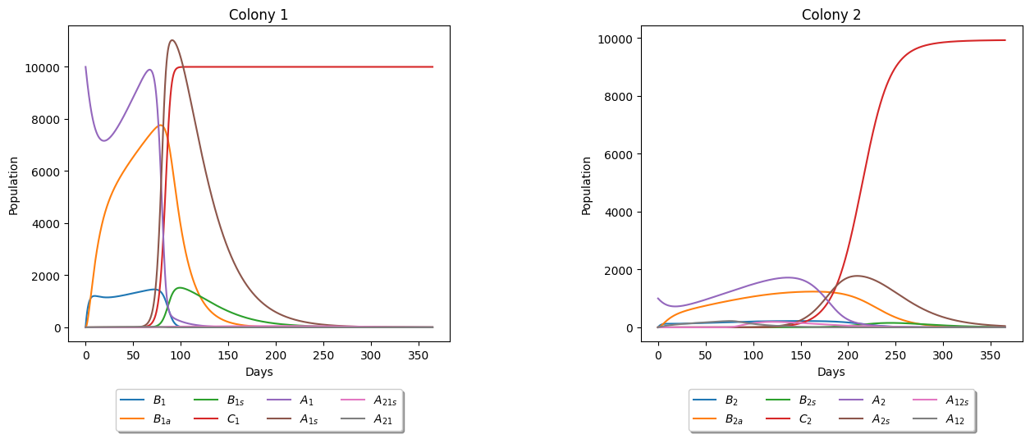

Figure 12. Dynamics of the two colonies with drifting infected adult honeybee from a weak Colony 2. Here, we set and. We also set the initial value of so that we weaken the Colony 2.

From the results, we observed that despite Colony 2 having the initial infected adult, Colony 1 is the first to collapse. This suggests that higher population density may accelerate the spread of AFB transmission within a colony. Further studies could explore whether population density serves as a critical factor in transmission dynamics.

We further investigated the dynamics using the model by varying important parameters that are likely to impact the trajectory of the system. Our initial exploration involves varying the parameter , which is detailed in **Table 3**, to observe its effects on the colony dynamics of both colonies, particularly with an infected adult honeybee present in Colony 2. The results are shown below.

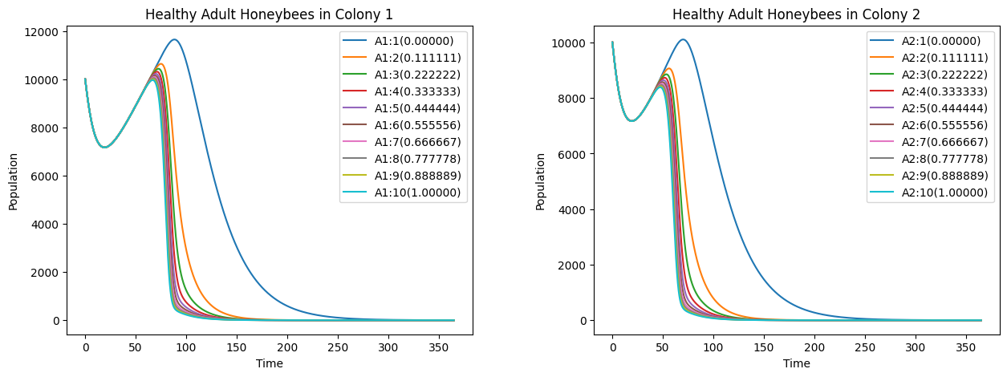

Figure 13. Effect of varying on adult honeybee dynamics with infected adult in Colony 2.

From the graphs depicted in **Figure 13**, we can see that for all values of from [0,1], the effect of  does not help much on the colony survival, specifically the adult honeybee population.

Now, let's examine its impact on the brood infection within the system. We can see the results in the following figure below.

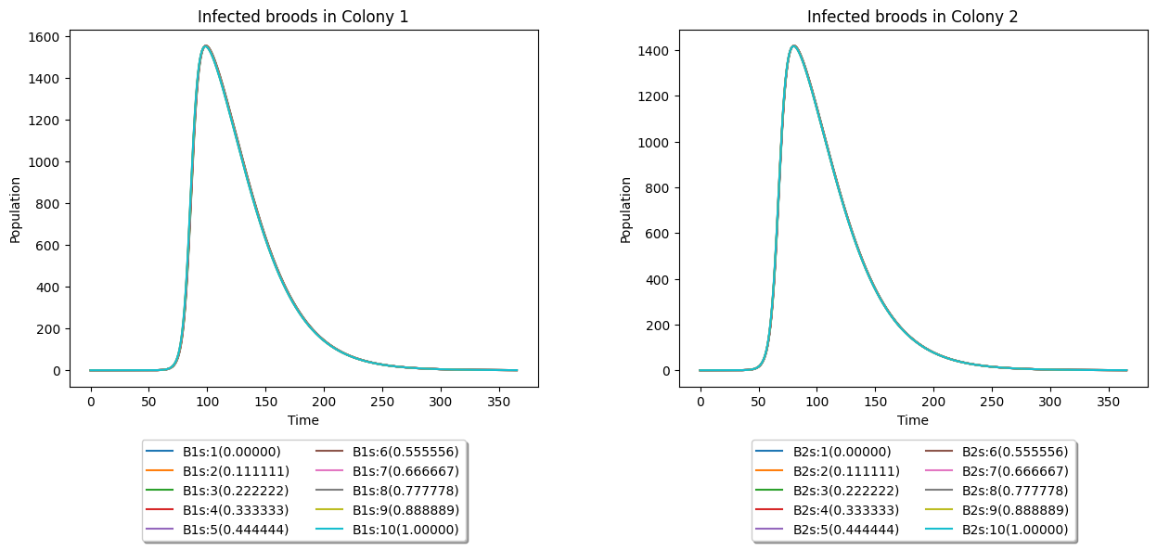

Figure 14. Effect of varying on brood dynamics with infected adult in Colony 2.

From the results above, it's evident that varying does not significantly influence the brood dynamics.

Next, we explored other infection rates for adult honeybees, like . Similar to , represents the rate at which adult bees become infected. The following figure showed how varying affects the adult honeybee population.

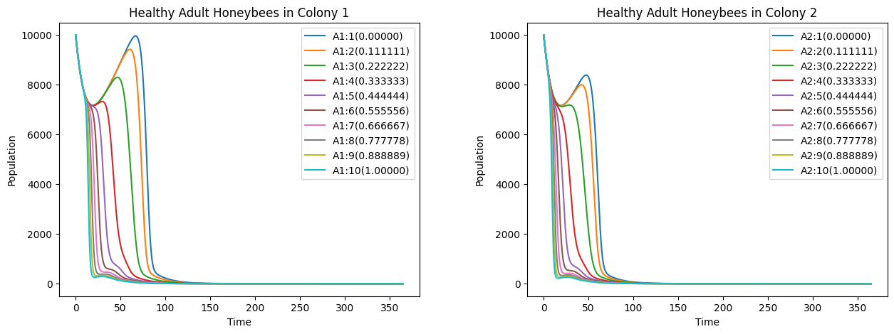

Figure 15. Effects of varying on adult honeybee dynamics with infected adult in Colony 2.

From **Figure 15**, any values from the batch runs ranging [0,1] does not affect much on colony survival. It is observed that increasing values up to 1 only prolong the lifespan of adult honeybees before eventual mortality.

We further investigated the effect of varying into the brood infection now. The results can be seen from the figure below.

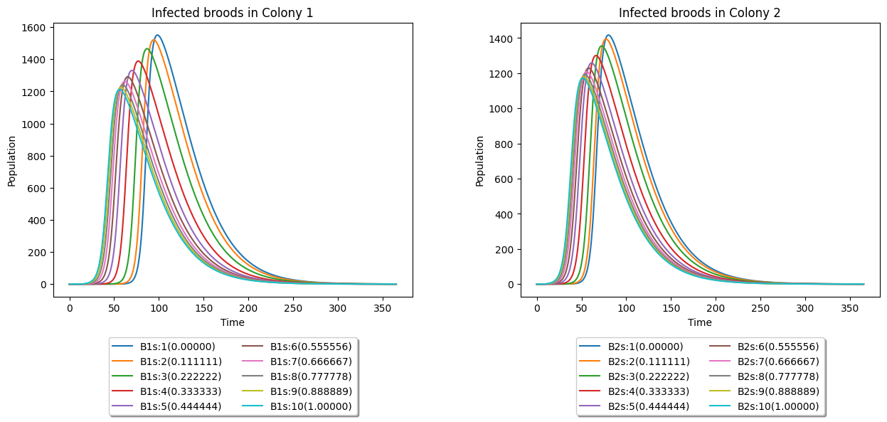

Figure 16. Effect of varying on brood dynamics with infected adult in Colony 2.

Based on the data presented in the figure above, it is apparent that infected broods will succumb to the infection across all values of within the range of [0,1]. Lower values of the parameter merely delay the eventual mortality of the infected broods.

Next, we explore another parameter related to infection rates: . Like the previous parameters, represents an infection rate, specifically concerning broods. We conducted experiments by varying , and the findings are presented below.

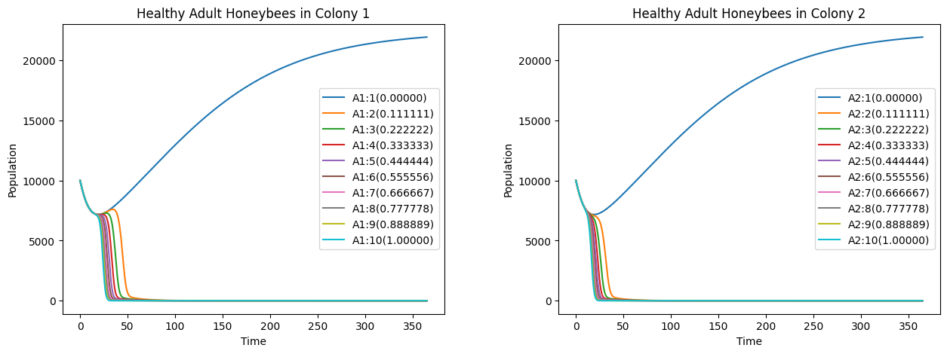

Figure 17. Effects of varying on adult honeybee dynamics with infected adult in Colony 2.

The findings from the graphs show a significant shift from the previous two parameters. We now observe a potential for adult honeybee survival when parameter is zero. Because of this, it is intriguing to also see what will happen to the brood dynamics. We can see the results from the following figure.

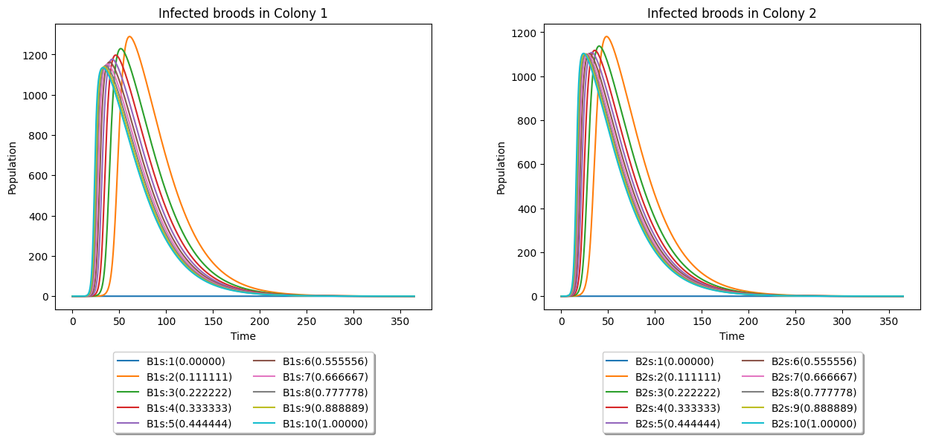

Figure 18. Effect of varying on brood dynamics with infected adult in Colony 2.

Correlating with the survival of adult honeybees, a notable observation arises when parameter , despite not being immediately apparent due to the graph displaying a flat line at 0. Both colonies in this scenario (varying ) exhibit survival without any infections. This finding holds significant implications, suggesting the critical importance of the infection rate among broods for colony survival and health. Consequently, it can be inferred that infected broods may constitute a more decisive factor in colony health and survival than infected adult honeybees. Further studies into these results is warranted.

Moving on from the infection rates parameters, we also studied the effects of varying on the adult honeybee population, which is the rejection rate of drifting honeybees from Colony 2 that are not accepted by the receiving colony, as discussed in **Table 3**. The results are shown below.

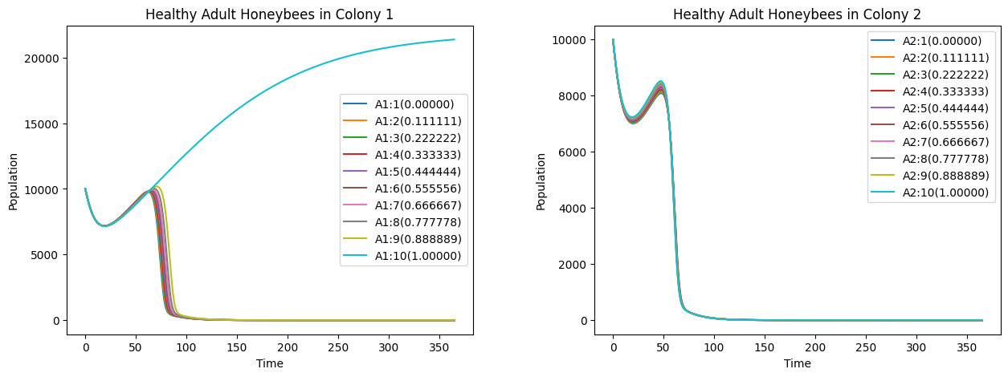

Figure 19. Effects of varying on adult honeybee dynamics with infected adult in Colony 2.

Based on the findings depicted in **Figure 19**, when Colony 1 consistently rejects all drifting adult honeybees from Colony 2, Colony 1 can survive without experiencing infection within its colony. Conversely Colony 2, where AFB infection initially originated, will still face colony collapse due to the presence of the disease.

Additionally, we investigated another parameter, , by conducting 10 batch runs to observe the effects of varying the rate at which diseased dead brood is cleaned by adult bees on the onset of the first brood infection. The results of these experiments are presented below.

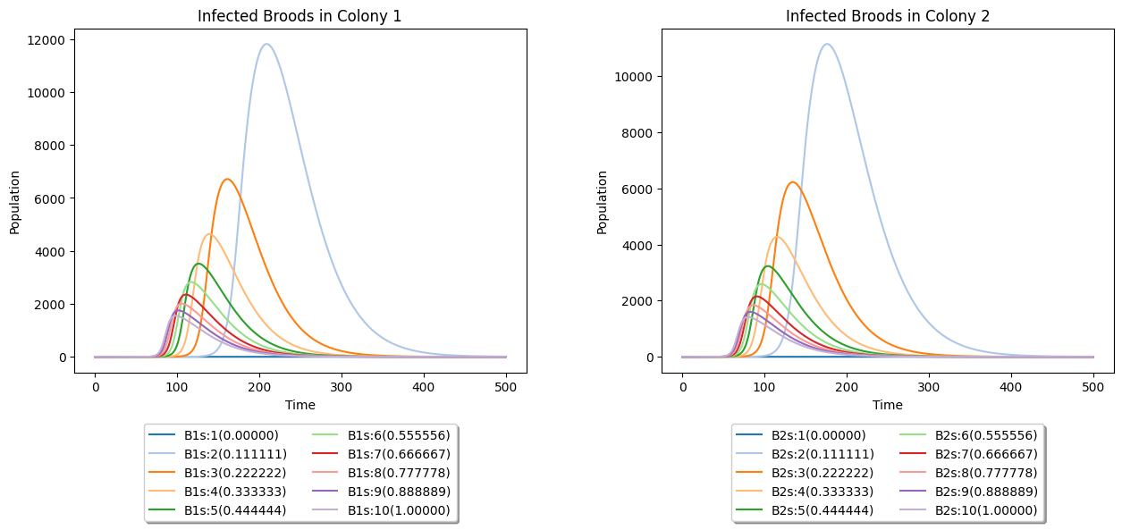

Figure 20. Effect of varying on brood dynamics with infected adult in Colony 2.

The observed graphs indicate that as the parameter decreases, the onset of the first brood infection decelerates, albeit with a higher peak population. Consequently, we conducted experiments with smaller values of this parameter and investigated their impact on the dynamics of adult honeybees. The findings are presented below.

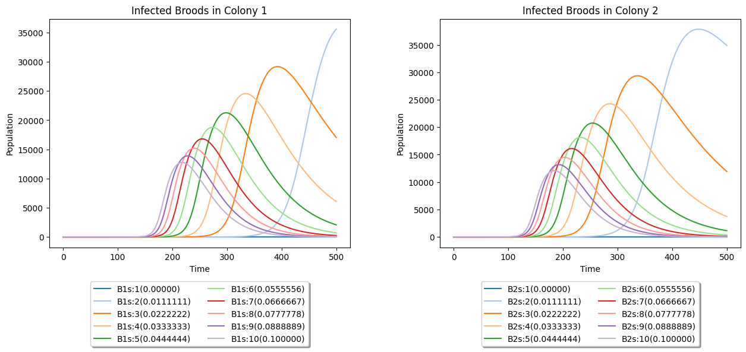

Figure 21. Effect of varying [0, 0.1] on brood dynamics with infected adult in Colony 2.

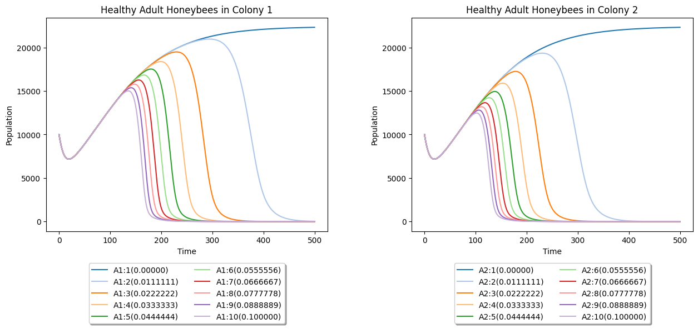

Figure 22. Effects of varying [0, 0.1] on adult honeybee dynamics with infected adult in Colony 2.

Further observations reveal that smaller values of lead to delayed onset of AFB infection; however, if left unaddressed, they result in more severe consequences in colony health.

Now, we proceeded to another important parameter, , which is the percentage of clean cell combs that will be contaminated by AFB spores (**Table 3**). The following results can be seen in the figures below.

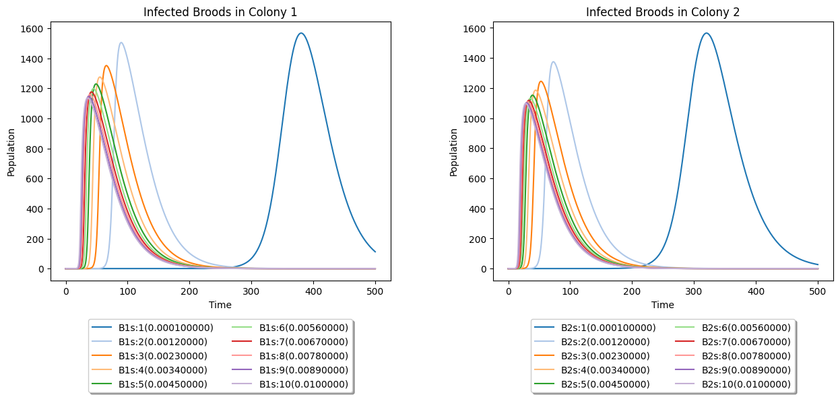

Figure 23. Effect of varying on brood dynamics with infected adult in Colony 2.

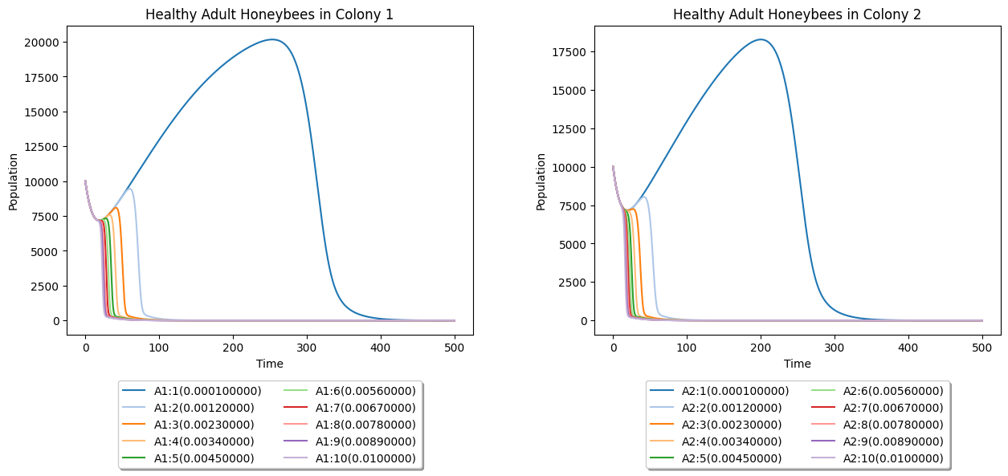

Figure 24. Effects of varying on adult honeybee dynamics with infected adult in Colony 2.

These results indicate that smaller values of also slow down the spread of infection within the colony. This suggests that apiary farmers may have more time to address the spread of AFB within their apiaries.

Based on these findings, we further explored the effects of different combinations of two parameters on brood infection onset using heat maps. Specifically, we varied both and , and the resulting heat map is depicted below.

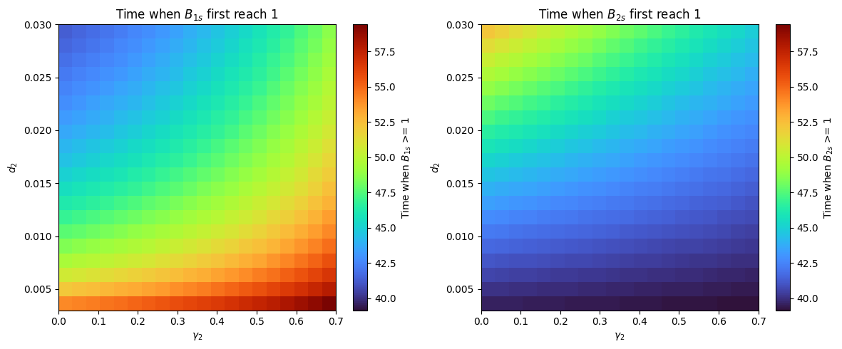

Figure 25. Effects of varying and on brood dynamics with infected adult in Colony 2.

Analyzing the heatmaps, we determined the relationship between different parameter combinations and the onset of the first brood infection in days. Notably, when is low and is high, the onset of brood infection occurs slower in Colony 1 but faster in Colony 2. This suggests that limited drifting in Colony 2 facilitates faster infection spread within their colony. Consequently, rejected adult drifters from Colony 2 have a higher likelihood of getting lost to another colony or returning to their own, accelerating the onset of infection.

Furthermore, we investigated the combined effects of two important parameters, and , on the onset of brood infection. The results are displayed in the heatmaps below.

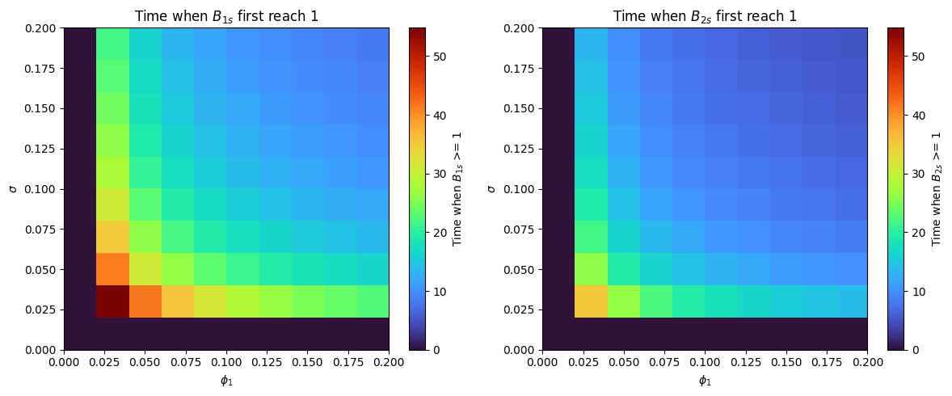

Figure 26. Effects of varying and on brood dynamics with infected adult in Colony 2.

Finally, the last simulation was the effect of varying the parameters, and . The importance of this relationship lies in how environmental contamination influences the likelihood and rate of infection transmission within the colony. A higher value means that more clean cell combs are contaminated, which in turn increases the exposure of adult bees to AFB spores and thus increases the likelihood of infection transmission, as captured by . The heatmap is shown below.

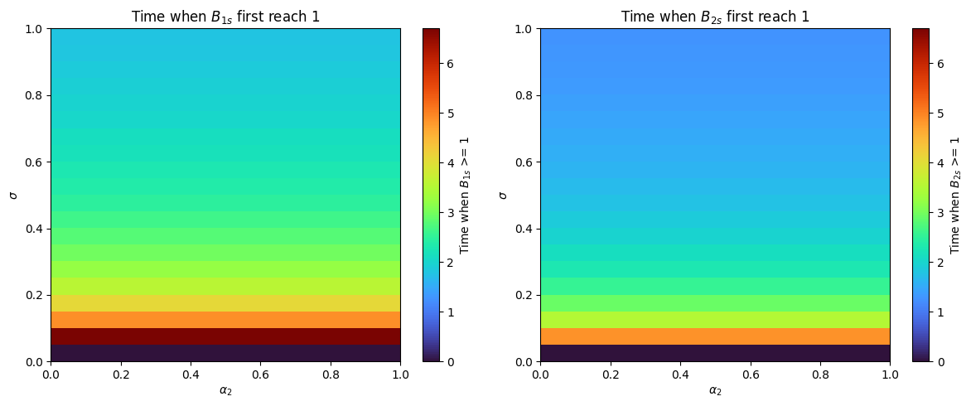

Figure 27. Effects of varying and on brood dynamics with infected adult in Colony 2.

From the heatmap above, we can see that does not really affect the first infection on broods. It is more important to look at , which denotes the percentage of clean cell combs contaminated by AFB spores, is particularly significant for assessing the vulnerability of honeybee colonies to AFB infection. A higher value of sigma indicates a greater likelihood of AFB contamination in the colony's brood cells, leading to more rapid and extensive spread of the disease.

The obtained result is further elaborated upon in the Discussion section of the paper.

# REFERENCES

1. American Foulbrood. Texas Apiary Inspection Service TAIS. (2017, May). https://txbeeinspection.tamu.edu/american-foulbrood/
2. Betti, M. I., Wahl, L. M., & Zamir, M. (2014). Effects of infection on Honey Bee Population Dynamics: A model. PLoS ONE, 9(10). https://doi.org/10.1371/journal.pone.0110237
3. Betti, M., & Shaw, K. (2021). A multi-scale model of disease transfer in honey bee colonies. Insects, 12(8), 700. https://doi.org/10.3390/insects12080700
4. Datta, S., Bull, J. C., Budge, G. E., & Keeling, M. J. (2013). Modelling the spread of American Foulbrood in Honeybees. Journal of The Royal Society Interface, 10(88), 20130650. https://doi.org/10.1098/rsif.2013.0650
5. Established pests. Bee Aware. (2014, July). https://beeaware.org.au/archive-pest/american-foulbrood/#ad-image-0
6. Ferrier, P. (2018, October 1). Despite elevated loss rate since 2006, U.S. honey bee colony numbers are stable. USDA ERS - Despite Elevated Loss Rate Since 2006, U.S. Honey Bee Colony Numbers Are Stable. https://www.ers.usda.gov/amber-waves/2018/october/despite-elevated-loss-rate-since-2006-u-s-honey-bee-colony-numbers-are-stable/
7. Garvey, K. K. (2013, September 24). The foraging force of a honey bee colony. ANR Blogs. https://ucanr.edu/blogs/blogcore/postdetail.cfm?postnum=11592
8. Gavina, M. K., Rabajante, J. F., & Cervancia, C. R. (2014). Mathematical programming models for determining the optimal location of beehives. Bulletin of Mathematical Biology, 76(5), 997–1016. https://doi.org/10.1007/s11538-014-9943-9
9. Jatulan, E. O., Rabajante, J. F., Banaay, C. G., Fajardo, A. C., & Jose, E. C. (2015). A mathematical model of intra-colony spread of American Foulbrood in European honeybees (apis mellifera L.). PLOS ONE, 10(12). https://doi.org/10.1371/journal.pone.0143805
10. Katzav-Gozansky, T., Ibarra, F., Francke, W., Hefetz, A., & Soroker, V. (2001). Dufour’s gland secretion of the queen honeybee ( apis mellifera ): An egg discriminator pheromone or a queen signal? Behavioural Ecology and Sociobiology, 51(1), 76–86. https://doi.org/10.1007/s002650100406
11. Khoury, D. S., Myerscough, M. R., & Barron, A. B. (2011). A quantitative model of Honey Bee Colony Population Dynamics. PLoS ONE, 6(4). https://doi.org/10.1371/journal.pone.0018491
12. Laomettachit, T., Liangruksa, M., Termsaithong, T., Tangthanawatsakul, A., & Duangphakdee, O. (2021). A model of infection in honeybee colonies with social immunity. *PLOS ONE*, *16*(2). https://doi.org/10.1371/journal.pone.0247294
13. Prado, A., Requier, F., Crauser, D., Le Conte, Y., Bretagnolle, V., & Alaux, C. (2020). Honeybee lifespan: The critical role of pre-foraging stage. Royal Society Open Science, 7(11), 200998. https://doi.org/10.1098/rsos.200998
14. Randy. (2023, May 8). A study on Bee Drift and mite immigration: Part 1. Scientific Beekeeping. https://scientificbeekeeping.com/a-study-on-bee-drift-and-mite-immigration-part-1/#:~:text=the%20drone%20factor.-,HOW%20MUCH%20DRIFT%20IS%20THERE%20OF%20WORKER%20BEES%3F,hives%20%5B%5B13%5D%5D.
15. Schmus, B. (2022, October 27). The honey bee lifecycle. The Best Bees Company. https://bestbees.com/2022/08/08/bee-lifecycle/
16. Spread of AFB: The Management Agency, National American Foulbrood Pest Management Plan New Zealand. The Management Agency, National American Foulbrood Pest Management Plan New Zealand | Elimination of American Foulbrood (AFB) Disease in New Zealand. (2019, April 11). https://afb.org.nz/spread-of-afb/
17. Staughton, J. (2024, March 19). What happens to bees when they get lost?. Science ABC. https://www.scienceabc.com/nature/animals/what-happens-to-bees-when-they-get-lost.html
18. Van Der Steen, J. (2015, February). The Foraging Honey Bee. Waginengen; Plant Research International.
19. Wildflowermeadows. (2019, October 22). Drifting. Wildflower Meadows. https://wildflowermeadows.com/2019/10/drifting/?fbclid=IwAR1bdt9f_t3ocsow-a6RSkcIFk_YGo_zio-1A6s8mpt3OO-b98wQymae2yE#:~:text=Looking%20at%20a%20large%20apiary,the%20correct%20colony%20each%20time
20. Willingham, R., Klopchin, J., & Ellis, J. (2021, July 20). Eny-163/IN1064: Robbing behaviour in Honey Bees. Ask IFAS - Powered by EDIS. https://edis.ifas.ufl.edu/publication/IN1064
21. Šekulja, D., Pechhacker, H., & Licek, E. (2014). Drifting Behaviour of Honey Bees (Apis Mellifera Carnica Pollman, 1879) in the Epidemiology of American Foulbrood. Zbornik Veleučilišta u Rijeci, 2(1), 345–358. https://hrcak.srce.hr/en/file/443139

Table 3. Significant parameters utilized in the model.

|  |  |  |  |
| --- | --- | --- | --- |
| **Parameters** | **Description** | **Value** | **Reference** |
|  | The queen’s maximum laying rate per day | , | [9, 10, 15] |
|  | A coefficient that influences the rate at which the term approaches as the number of adult bees in a colony gets large [11]. |  | [9, 11] |
|  | The rate at which broods are infected by colony spore-carrying adult bees | , | [9] |
|  | The rate at which adult bees become infected by the infected cell | , | [9] |
|  | The rate at which adult bees become infected upon contact with spore-carrier adult bees | , | [9] |
|  | The rate at which broods become immune with the spores |  | [9], calculated from [12] |
|  | The rate at which immune broods become adult bees |  | calculated from [12] |
|  | The death rate of infected broods | variable, | [9, 12] |
|  | The rate at which a diseased dead brood is cleaned by adult bees | variable, | [9, 12] |
|  | The maximum number of cells in the colony |  | [9] |
|  | The percentage of clean cell combs that will be contaminated by AFB spores |  | [9] |
|  | The death rate of adult bees (both spore-carrier and spore-free) |  | [9] |
|  | The rate at which honeybees drift multiplied by the percentage of foraging honeybees | , , * | calculated from [18] and [21] |
|  | The rejection rate of drifting honeybees that are not accepted by the receiving colony. |  | [17] |
|  | The rate at which drifting adult bees return to their original colony after failing to integrate into the other colony. | , | [12, 13] |

*the subscript representing the two colonies.

*~1% drift rate [21] x ~30% are foragers [18]

Table 4. Description of the state variables.

|  |  |
| --- | --- |
| **Variables** | **Description** |
|  | The number of infected broods in colony 1 |
|  | The number of healthy broods in colony 1 before hours old ( depends on the susceptibility of bees) |
|  | The number of healthy broods in colony 1 beyond hours old |
|  | The number of infected cell combs in colony 1 (due to diseased dead brood) |
|  | The number of adult bees with AFB spores in colony 1 |
|  | The number of adult bees without AFB spores in colony 1 |
|  | The number of infected broods in colony 1 |
|  | The number of healthy broods in colony 2 before hours old ( depends on the susceptibility of bees) |
|  | The number of healthy broods in colony 2 beyond hours old |
|  | The number of infected cell combs in colony 2 (due to diseased dead brood) |
|  | The number of adult bees with AFB spores in colony 2 |
|  | The number of adult bees without AFB spores in colony 2 |
|  | The number of infected adult bees from colony 2 that drift into colony 1. |
|  | The number of adult bees from colony 2 that drift into colony 1. |
|  | The number of infected adult bees from colony 1 that drift into colony 2. |
|  | The number of adult bees from colony 1 that drift into colony 2. |